5th Grade Science

Element Cards

May 2018

NGSS SC.5.N.1.2 Explain the difference between an experiment and other types of scientific investigation
Access Point Type | Access Point
Independent | SC.5.N.1.In.2 Identify the basic purpose of an experiment.
Supported | SC.5.N.1.Su.2 Identify the result of a simple experiment.
Participatory | SC.5.N.1.Pa.2 Recognize that people use observation and actions to get answers to questions about the natural world.

Suggested Instructional Strategies:

Write to Understand
Direct teach the steps of the scientific method using PowerPoint or text. Have students complete a graphic organizer to write the steps of the scientific method. For example:
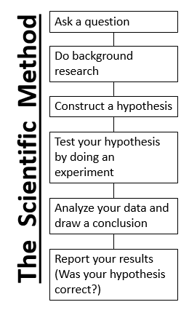

Discuss to Understand
Work through an experiment as a class. Fill out a graphic organizer of each step, data, results and conclusion as you work through the steps. Have students identify the purpose and the results of the experiment. For Example:
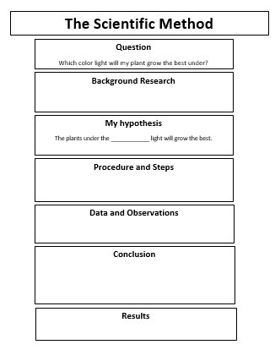

Sort to Understand
Activity 1: Present students with three picture options. Ask: Which picture shows a person answering a question about science?
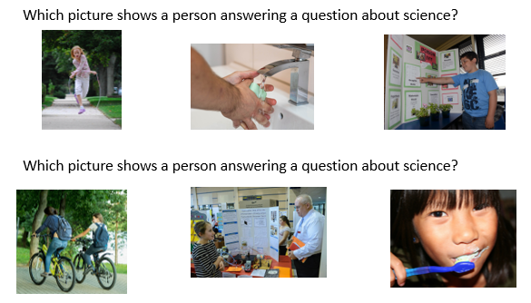
Activity 2: match the purpose of an experiment with the experiment (question)
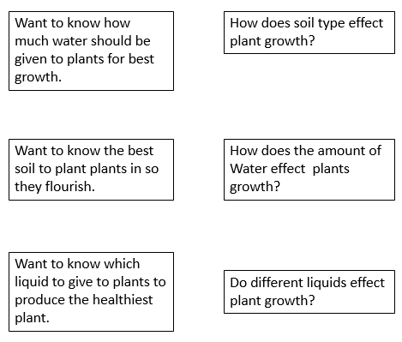
Activity 3: Present students with picture choices from a completed science experiment and have students identify the best result of the experiment. Example:

Which plant appears to have had the best growth? A, B, C, D, E, or F?
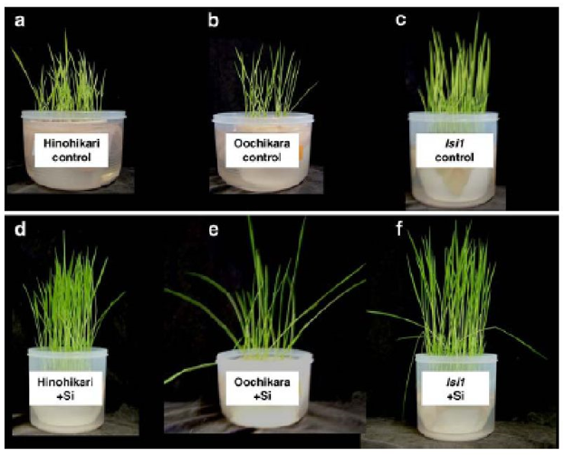
Which Candle burned the longest? Red or White?
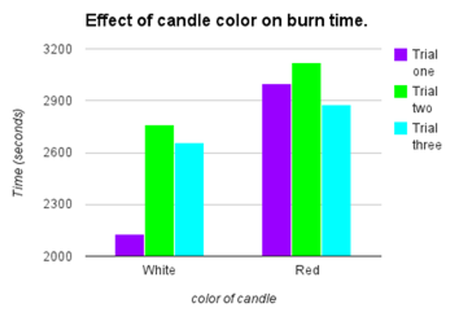

Scaffolds and Supports
- Interactive whiteboard
- Graphic Organizers
- Document Camera
- Hands on Activities
- Repeated exposure to content
- Small group instruction

Additional Resources
- BrainPop: Click Here

NGSS SC.5.P.10.4 Investigate and explain that electrical energy can be transformed into heat, light, and sound energy, as well as the energy of motion.
Access Point Type | Access Point
Independent | SC.5.P.10.In.4 Demonstrate that electricity can produce heat, light, and sound.
Supported | SC.5.P.10.Su.4 Recognize examples of electricity as a producer of heat, light, and sound.
Participatory | SC.5.P.10.Pa.4 Identify one source of sound, heat, or light that uses electricity

Suggested Instructional Strategies:
Write to Understand
Provide students with pictures and words of the steps to using a battery to light a light bulb. Work through the steps as a class and have students place the steps in order on a graphic organizer. Have students repeat the project in small groups following the steps to demonstrate. See worksheet example in link below.

Discuss to Understand
Direct teach that electricity can produce heat, light and sound through PowerPoint or text. Show examples of a variety of sources of heat, light and sound. Provide students with two images at a time and have students select the image that shows the heat, light or sound from an electrical source. See worksheet example in link below.
Sort to Understand
Provide students with a graphic organizer and picture examples of electricity that produces heat, light and sound. Have students sort each picture into its correct category. See worksheet example in link below.

Scaffolds and Supports
- interactive whiteboard
- graphic organizer
- small group instruction
- repeated exposure to content
- hands on activity
- Electrical Energy Sort Click here
- What Source is Electrical Click here
- Demonstrating That Electricity Can Produce Light Click here

Additional Resources
- BrainPop: Click Here

NGSS SC.5.L.14.1 Identify the organs in the human body and describe their functions, including the skin, brain, heart, lungs, stomach, liver, intestines, pancreas, muscles and skeleton, reproductive organs, kidneys, bladder, and sensory organs.
Access Point Type | Access Point
Independent | SC.5.L.14.In.1 Distinguish major external and internal body parts, including skin, brain, heart, lungs, stomach, muscles and skeleton, reproductive organs, and sensory organs.
Supported | SC.5.L.14.Su.1 Identify major external and internal body  parts, including skin, brain,  heart, lungs, stomach, and  sensory organs.
Participatory | SC.5.L.14.Pa.1 Recognize body parts related to movement and the five senses.

Suggested Instructional Strategies:
Write to Understand
Direct instruct the major external and internal body parts through PowerPoint or text. Provide students with a graphic organizer with the body parts listed on the left side. Have students write a short description to include the function of each body part. For example:
Discuss to Understand
Activity 1. Direct instruct major body parts and their location within the body through PowerPoint or text. Have students label the major body parts on a chart to help them learn to identify the body parts. See example below.
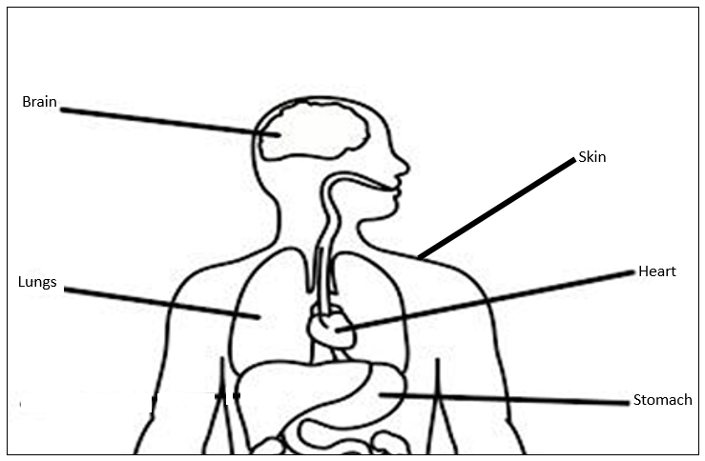
Activity 2 - Provide students with two choices of body parts and a function for a given picture. Have students name the body part that would be used for that function. See example (Which organ is it?) below.
Sort to Understand
Provide students with concentration card game. Have students flip cards to play concentration to match each body part with its correct description. See concentration game example below.

Scaffolds and Supports
- Interactive whiteboard
- graphic organizers
- Body Part (add link)

Additional Resources
- BrainPop: Click Here

